**EXPERIMENT 1**

**NAME: Vishal Shashikant Salvi UID: 2019230069**

**CLASS: TE COMPS BATCH: C**

**Aim: Analysis of failed project.**

**Theory:**

In late August 2009, the same year the company became the world’s number one auto brand an off-duty California policeman was driving a Toyota Lexus that accelerated in excess of one hundred miles per hour and crashed, killing the officer and his family. The incident received news coverage that featured a recorded cell phone call to 911 documenting that the acceleration was uncontrolled, and the driver had no part in the sudden acceleration. In part because of the novel, TV-friendly existence of the 911 cell phone recording, this became a story in the electronic media and spiked existing concerns about whether Toyota vehicles suffered from an electronic defect that caused uncontrolled acceleration in turn putting pressure on federal safety regulators responsible for protecting the public.

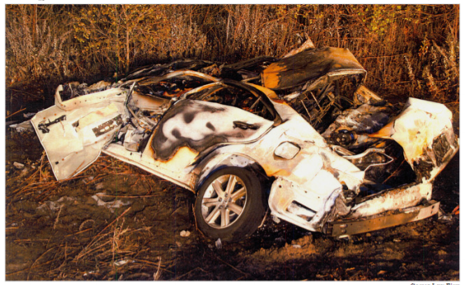**Problem:**

In the mid-2000’s many Toyota drivers were reporting that their car was accelerating without them touching the pedal. After a series of accidents, which lead to investigations, investigators discovered that software errors were the cause of the unintended acceleration. In this case, there was a series of things wrong with the software installed in Toyota cars: Memory corruption, wrong memory handling, disabling safety systems, systems with single points of failure, and thousands of global variables. Toyota recalled millions of vehicles and Toyota’s stock price decreased 20% a month after the cause of the problem was discovered. This case demonstrates the consequences of not giving enough attention to good programming practices and testing as a result of wanting to launch the product.

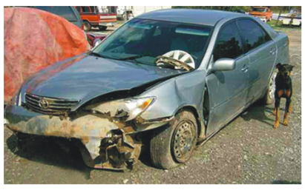

**Project Objectives:**

* Cost Management.
* Quality Production.
* Resources utilization.
* To maximize shareholder’s wealth and giving them returns on their capital invested.

**Project Outcomes:**

* Upgrade previous Toyota Corolla model.
* Customer safety Precautions.

**Issues:**

1. The average mileage of these Corollas was almost 100,000 miles.
2. The airbags simply failed to deploy and that caused injuries to the owners and their occupants.
3. In 2009 Corolla had a lot of speed control and steering issues.
4. These issues were serious, and the results were many crashes and many injuries.
5. Car Complaints says that over 100 crashes were caused by these issues, and over 50 injuries were the result of them as well.
6. Its airbags would also sometimes not deploy, but other times when they did deploy, apparently an explosion could happen that could injure or even kill the occupants. Car Complaints reports that over 40 people have been injured by this, and unfortunately, one person died.
7. Like the speed control and steering issues however, [Toyota also issued](https://www.motorbiscuit.com/drivers-report-this-is-the-most-frustrating-feature-on-some-toyota-tundra-model-years/) a nationwide recall over this. Millions of vehicles, including the 2009 Corolla, were included in this recall.
8. Toyota drivers were reporting that their car was accelerating without them touching the pedal.
9. After a series of accidents, which lead to investigations, investigators discovered that software errors were the cause of the unintended acceleration.
10. There was a series of things wrong with the software installed in Toyota cars: Memory corruption, wrong memory handling, disabling safety systems, systems with single points of failure, and thousands of global variables.

**Actions to be taken:**

1. Recalled millions of vehicles.
2. Resolved the issues that, software installed on these Toyota cars had a variety of issues like memory corruption, disabling safety systems, incorrect memory handling, and systems with single points of failure.
3. Solved airbags problem.
4. By looking within real time operating system, the experts identified “unprotected critical variables.” They obtained and reviewed the source code for “sub-CPU”, and they “Uncovered gaps and defects in the throttle fails safes.”
5. Focus on speed control and steering issues.

**Feasibility of solution:**

The solution is quite feasible, Toyota Recalls millions of vehicles for investigation. During the trial, embedded systems experts who reviewed Toyota’s electronic throttle source code testified that they found Toyota’s source code defective, and that it contains bugs, including bugs that can unintended acceleration.

**Conclusion:**

Thus, we studied a failed project and suggested method that could be taken to prevent such failures in future.

**What is failure and what is success with respect to IT projects?**

Project failure can be defined as a “project that fails to perform a duty or an expected action, non-occurrence or non-performance”

Project success can be defined as the achievement of something desired, planned or attempted. It is also said that success is an event that accomplishes its intended purpose.

Meaning that the scope, goals, and objectives were met, the project was completed on time, and the project came in at or under budget.

**Why do IT projects fail?**

1. Unclear Goals and Objectives

### 2. Lack of resource planning

### 3. Lack of project visibility

### 4. Communication gaps

### 5. Scope creep

### 6. Unrealistic expectations